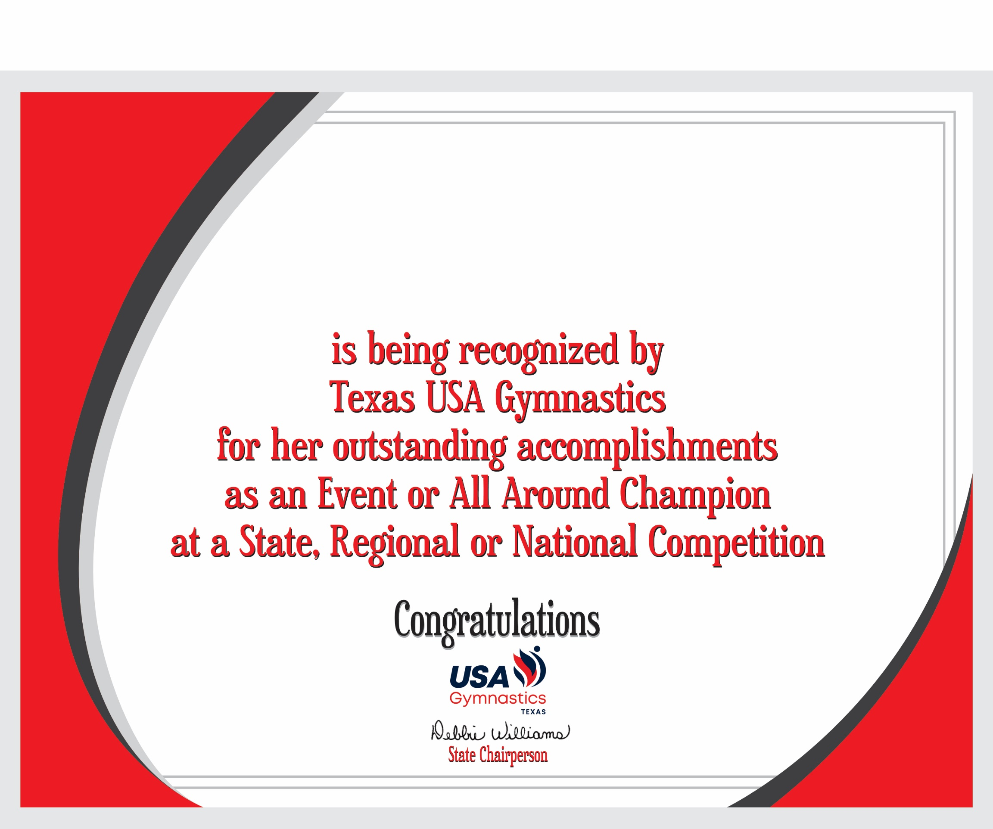

Julliet Adeliyi

Ragan Aduddell

Kennedy Alkire

Avery Allen

Giselle Allen

Sophie Alvarenga

Harper Alvarez

Madaley Arellano

Madysen Arellano

Kaylyn Armstrong

Mackenzie Atkinson

Catalina Ayala

Avery Bacorn

Addison Baer

Kathryn Baker

Amiya Barrett

Lizzy Belousov

Savannah Benet

Elizabeth Betancourt

Rylee Betts

Emma Biehl

Emma Birenbaum

Ellie Blanchard

Sutton Blanchard

Whitney Blount

Zoey Blum

Adelaide Bonilla

Catie Bopp

Ember Bosse

Peyton Bowers

Dallas Boyd

Reecy Brabham

Reyse Braddock

Keylee Bradshaw

Natalie Brandt

Madelyn Breaux

Annabelle Bright

Blaire Brown

Peyton Brown

Aspen Brummett

Laurel Bullard

Alexis Bullitt

Brooklyn Burks

Emma Burroughs

Eleanor Byers

Addison Calime

Brooklyn Cansino

Zaiah Canto

Talia Cardona

Olivia Catamin

Emma Cearley

Kaylee Cessna

Liliana Cesta

Cora Chavez

Viva Cintron

Paola Ciofuli

Ryleigh Clark

Winslet Clark

Jordyn Clewis

Marielle Collie

Mallory Conway

Haley Cooley

Ava Cooney

Sofia Cordero

Brooklyn Coyle

Lucy Crafton

Tylie Crispen

Victoria Cruz

Lailah Dawson

Maria Elena Rojas D'Cesare

Jules Demarest

Mila Deoja

Adelyn Diaz

Shay Donohue

Zaila Dorroh

Savannah Doser

Aubrey Drake

Ella Dunkeson

Ryder Dushane

Chloe Eber

Milah Elliott

Camila Escudero

Lily Eubanks

Ora Farchi

Madelynn Fellman

Yaya Fenley

Alli Ferguson

Brynn Fetig

Elsee Fewkes

Olive Filbert

Mariposa Flynn

Addison Fojtik

Lilly Frederick

Helena Fribourg

Hope Furth

Nina Galang

Lilly Galicia

Lexi Garner-Kitts

Kessleigh Germany

Laura Ginsberg

Harper Glenn

Emma Gonzales

Patricia Gonzales

Gabrielle Gordon

Kendall Graham

Natalie Greene

Rya Grinblatas

Anastasia Grundler

Seray Gursel

Keayana Haase

Leila Haleck

Lennox Haleck

Madi Halmai

Emma Halstead

Allysin Halvorsen

Caroline Hammer

Hollyn Hamon

Ella Hang

Emma Hang

Olivia Hare

Isabelle Hearon

Harper Henderson

Kate Henrichs

Addison Hernandez

Aileen Hernandez

Sunni Herrera

Ashlyn Hodges

Molly Hoffman

Juliette Hood

Teagun Hookfin

Zoe Houseman

Parker Huber

Coco Hughes

McKenna Hunter

Ellie Hutchinson

Emma Johnson

Riley Jones

Piper Joyal

Saige Kelley

Monica Key

Emily Kim

Aubrey Kimbrell

Torie Kimbrell

Emerson Knighton-Schooler

Jaelle Kong

Paige Koym

Isabella Kyong Kurtzweil

Camila Trujillo Labrana

Aidyn Lagroue

Cambrya Lara

Sloane Larson

Emma Latham

Taziva Lawrence

Baylee Leal

Landry Lewis

Nemyra Lewis

Rebekah Lewis

Lyric Lowman

Alexia E. Lozano

Esperanza Fowler Luna

Penny Lyons

Ari Mack

Chloe Grace Malandris

Ellah Malnory

Julia Manczko

Kellee Manning

Nyla Manning

Emma Mariani

Mischa Markman

McKinley Martin

Emeline Martinez

Kyra Martinez

Abigail Marx

Naomi Mass

Presley Maxwell

Ze'Niyah Maxwell

Claire McClure

Taylor McDaniels

Isabella McDonald

Chloe McHale

Harper McKee

Mila McPherson

Madison Medina

Maddie Mendoza

Sage Metzger

Jessica Meyers

Kennedy Middleton

Sophie Grace Miles

Rylee Mitchell

Shelby Mitchell

Ivana Mitric

Karlie Mixa

Landri Moore

Julia Morgan

Makaylee Morrison

Karina Mosteller

Stella Moya

Harmonie Murray

Sarah Nobinger

Makenzie O'Brien

Emma Ofczarzak

Brisa Oiboh

Marialuzena Oliveros

Elly Ortman

Arantza Antonella Aguilar Palacios

Bella Cantu Paletykina

Brooke Parker

Kirsten Partlow

Tatym Patke

Brooke Payne

Emma Payne

Zoe Pearsall

Rose Pena

Jessica Peterson

Samantha Pirela

Mia Pistana

Avery Plummer

Jayden Pollard

Ava Poursepanj

Kaylee Price

Lyla Procopio-Bridges

Piper Quinn

Ana Iram Franco Quintero

Jannat Rafique

Emma Ramsey

Alayna Randall

Nicole Ravanzo

Ryan Richardson

Catherine Rivas

Addison Rivera

Brooklyn Robbins

Avery Rodgers

Valentina Rodgers

Adriana Rodriguez

Bella Rudd

Ellie Samples

Chloe Sandel

Peyton Saner

Savannah Sanford

Ellison Schaal

Staton Schonier

Karastyn Schuerger

Karisa Schultz

Ella Schwerin

Adalynn Shadden

Neha Sharma

Madison Sharp

Molly Shary

Kayla Shekari

Quynne Shevchuk

Viola M. Silva

Sarah Simar

Zoe Simmons

Audra Smith

Claire Smith

Olive Smith

Zoey Smith

Zoie Smith

Daniela Sonnen

Roberta Soto

Haley Stanley

Jayci Stanley

Aubrey Stoltenberg

Makenzie Strack

Evalyn Stroh

Emily Struve

Riley Sublett-Bryant

Abigail Summerville

Jessica Taylor

Morgan Taylor

Naomi Thao

Alaina Thesing

Millie Toal

Michelle Todorova

Landry Tumis

Davany Valdez

Natalie Valdez

Lydia Valleskey

Camille Vance

Sophia Vega

Avery Vera

Jayleen Verdin

Audrey Villarreal

Dilara Villegas

Victoria Vinson

Kendall Wall

Eva Watson

Bryn Watts

Juliet Weber

Ava Williams

Madison Williams

Amelia Wilson

Jaidyn Wise

Ava Yates

Kendall Yazdchi

Shaylee York

Alana Zamora

Lily Zapata

Zoya Zarak

Natalie Zellefrow

Emma Zigler

